BLUETOOTH4.2
/WIRELESS 11AC 650M
WL-700RXS-BT
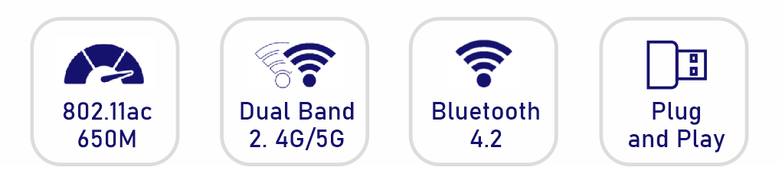
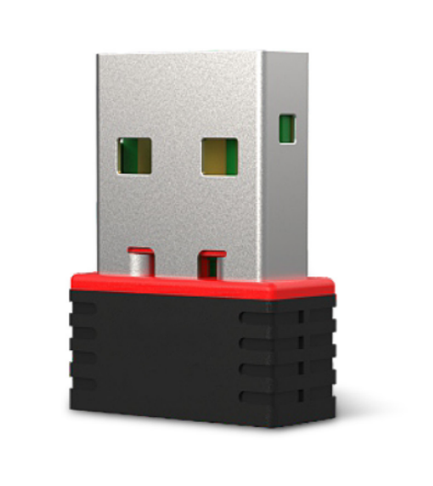
Link to Your Computer via Bluetooth
It is not only 11AC 650M wireless adapter but also USB Bluetooth Adapter. It is easily adds bluetooth to your Windows computer that doesn't already have it and provides wireless connections between your computer and Bluetooth headsets, headphones and speakers, along with Bluetooth mice, keyboards, and other device at speed of up to 3 Mbps from up to 50 feet away.

Wi-Fi driver installation
1. Put the CD in the driver and ggen "computer, and then double-click to enterit as Icon of CD driver, It will pop up the inallation wizard page to cick
"Wi-Fi drver".Wait for a few seconds and cick Instal" to complete the insalltion,
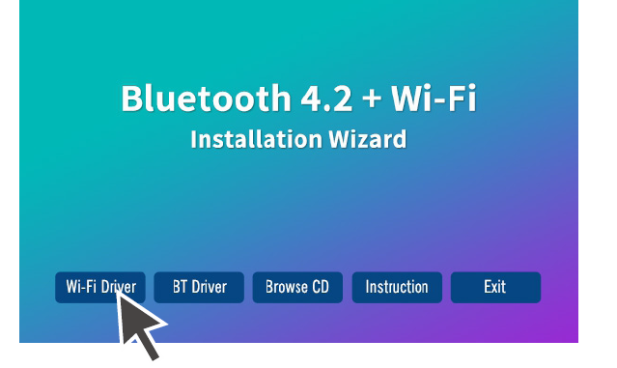
2. Click the icon in the lower right corner of the desktop, and then choose the name of wireless network, click the "connect" button, and it will be displayed as "connected",indicating that the network has been successfully connected.
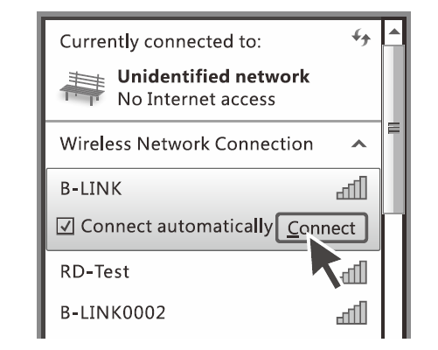

Bluetooth driver installation
1.Put the CD into the driver and open "computer", and then double-click to enter the CD driver displayed as an icon It will pop up the installation wizard page to click "BT driver" and choose installation according to your computer's operating system. Wait for a few seconds and click "next" to complete the installation.
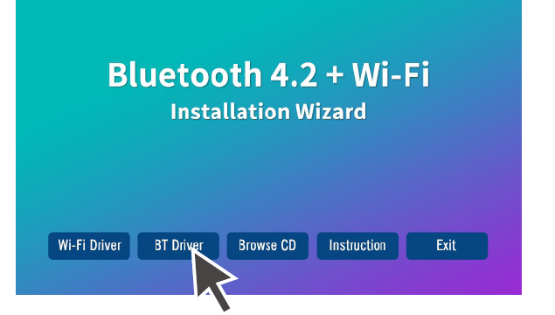
2.Click the Bluetooth icon in the task bar and click "add device". When the mobile phone of Bluetooth function is turned on and the computer will search for the Bluetooth information of mobile device. Click "next", the computer side will have a verification code, click pair in the phone side. You could use normally with the Bluetooth function.
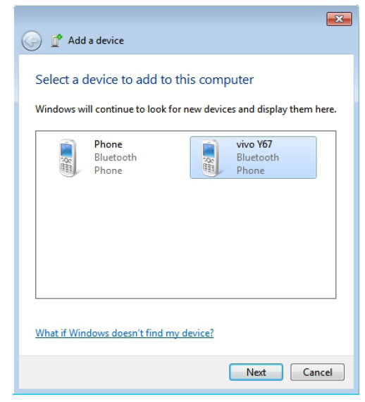
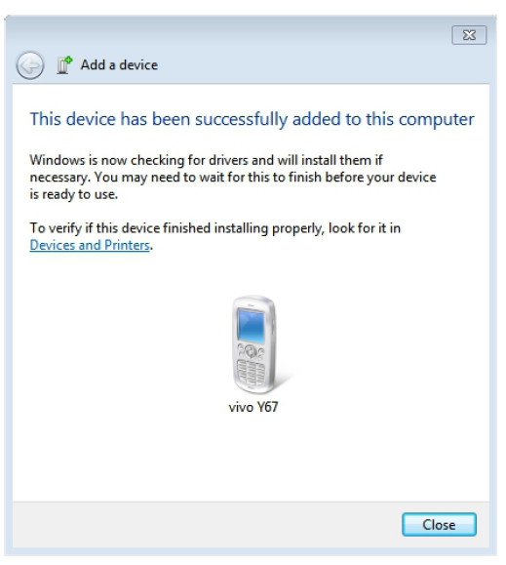

After insert the Driver CD, the setup wizard does not pop up, what should I do?
1. Please open "Computer", and find the " CD". Double click on "autorun.exe"
to run it.
2. Make sure that the computer is configured to auto-play media, and that all devices can use auto-play.

If l installed the driver, but I still can't use the wireless
USB N adapter, what should I do?
1. Try another USB port on the computer.
2. Make sure that the computer does not have a similar driver already installed, if so,uninstall the other driver, then plug in the wireless adapter again.

